- Replace the whole-word occurrence of a pattern using sed

- cat -n f2 [ To display the content of f2 with line numbers, in order to locate occurrences of the word "morning" ]
- sed -z 's/\<morning\>/evening/6' f2 [ To treat the whole file as a single string (-z) and replace only the 6th whole-word occurrence of "morning" with "evening", without saving the change to disk ]

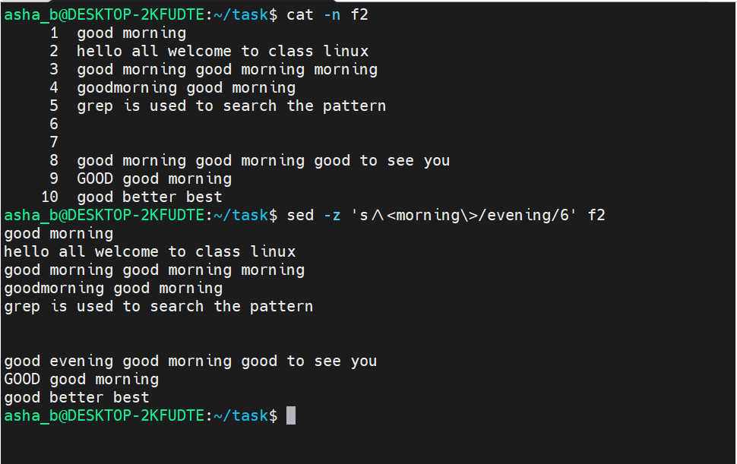

- sed -z -i 's/\<morning\>/evening/6' f2 [ To treat the whole file as a single string (-z) and replace only the 6th whole-word occurrence of "morning" with "evening" and save the change in original file using -i ]
- cat -n f2 [ To verify the change is now permanently saved in f2 ]
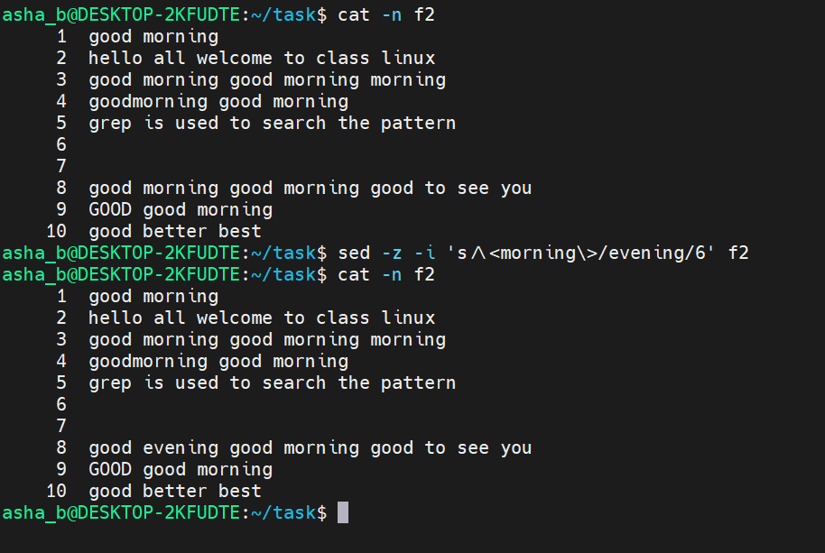

- Print specific lines of a file using sed

- sed -n '5p' f2 [ To print only line 5 of the file ]
- sed -n '2,6p' f2 [ To print lines from 2 to 6 of the file ]
- sed -n '5,$p' f2 [ To print from line 5 to the last line of the file ]

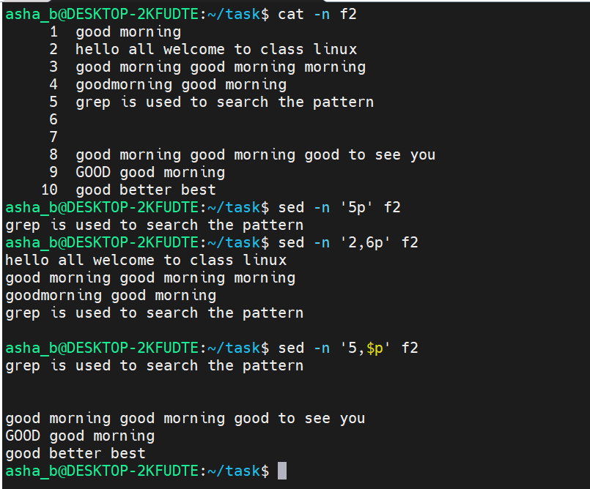

- Delete specific lines of a file using sed

- sed '4d' f2 [ To delete line 4 from the output ]
- sed '3,8d' f2 [ To delete lines from 3 to 8 from the output ]

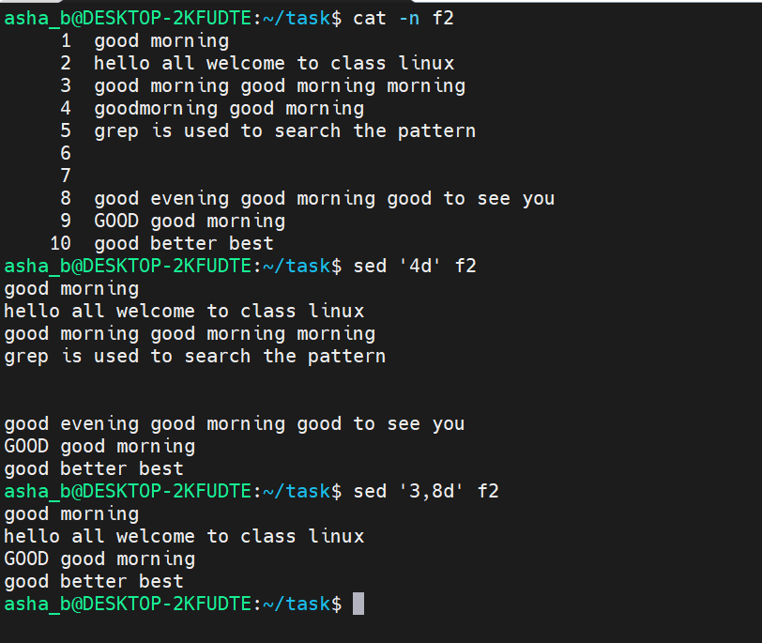

- sed '5,$d' f2 [ To delete from line 5 to the end of the file, in the output only ]
- sed -i '5,6d' f2 [ To delete lines 5 and 6 and save the change in original file ]
- cat -n f2 [ To verify lines 5 and 6 are permanently removed from the file f2 ]
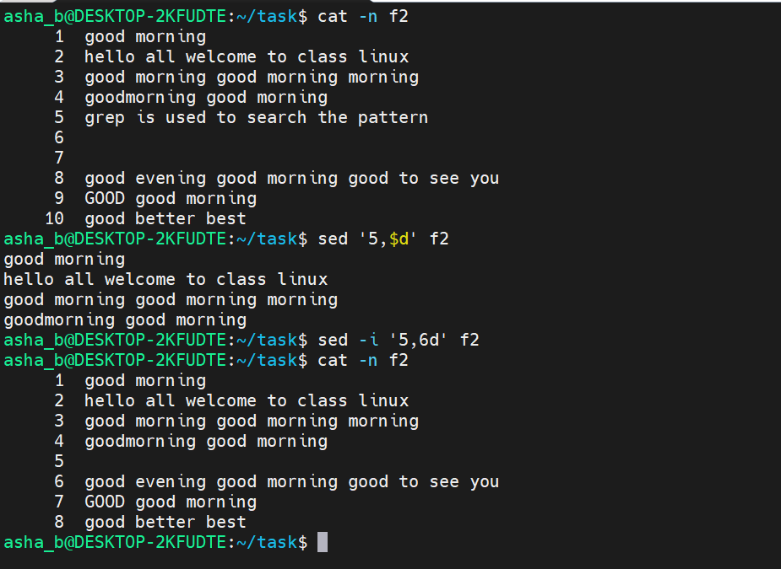

- Apply multiple sed expressions in a single command

- sed -e '3s/good morning/GOOD MORNING/2' -e 's/welcome/introduction/' -e '7s/good/pleasant/i' f2 [ To apply three substitutions in one command: replace the 2nd occurrence of "good morning" on line 3, replace "welcome" with "introduction" wherever it first appears, and case-insensitively replace "good" with "pleasant" on line 7 ]

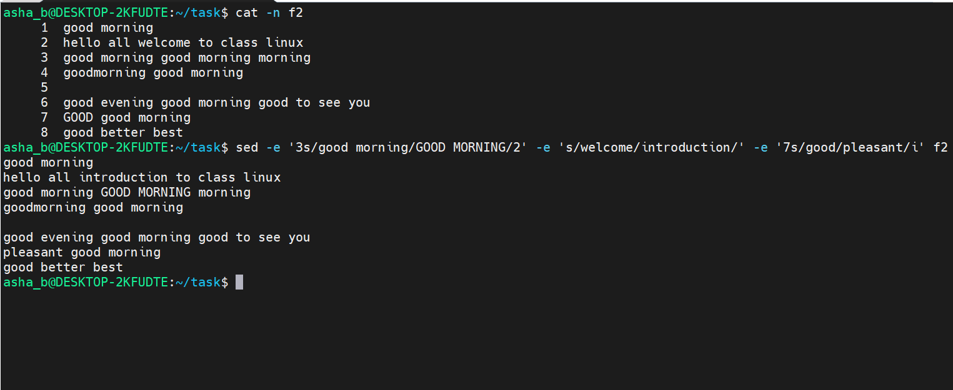

- View file/directory listing and disk usage

- ls -lrt [ To display a detailed listing of files, directories and links with permissions, owner and size ]
- du [ To display the disk usage of each file/subdirectory in KB ]
- du -h [ To display the disk usage in a human-readable format ]

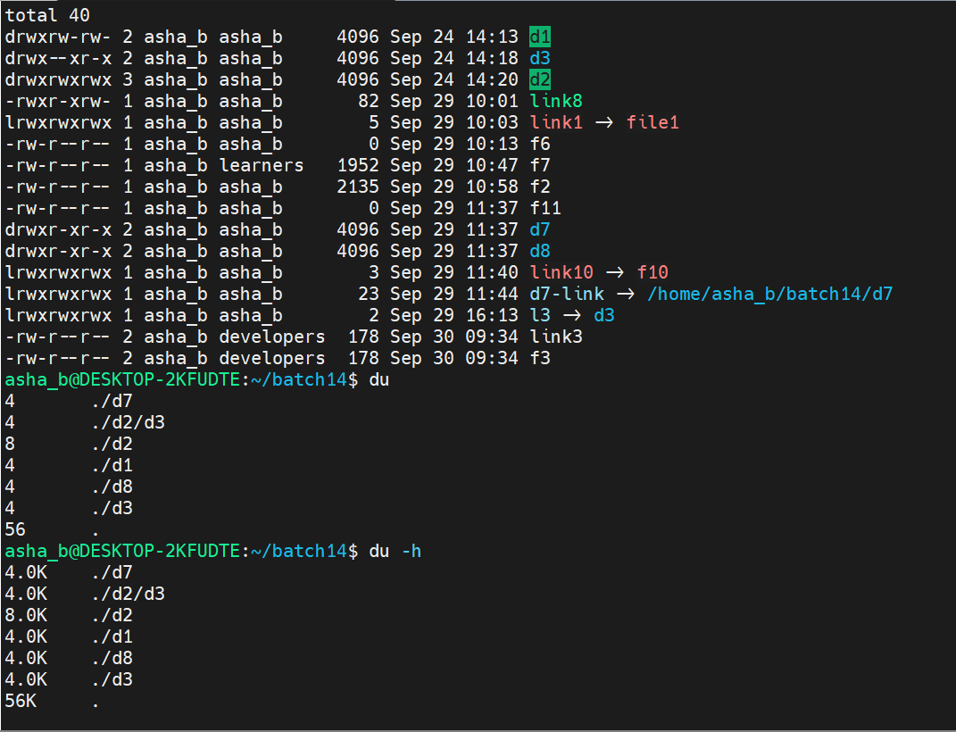

- ls -lrt [ To display file/directory details sorted by modification time ]
- du -h d2 [ To display the human-readable disk usage of directory d2 ]
- du -h f2 [ To display the human-readable disk usage of file f2 ]
- du d2 [ To display the disk usage of directory d2 in KB ]
- du f2 [ To display the disk usage of file f2 in KB ]
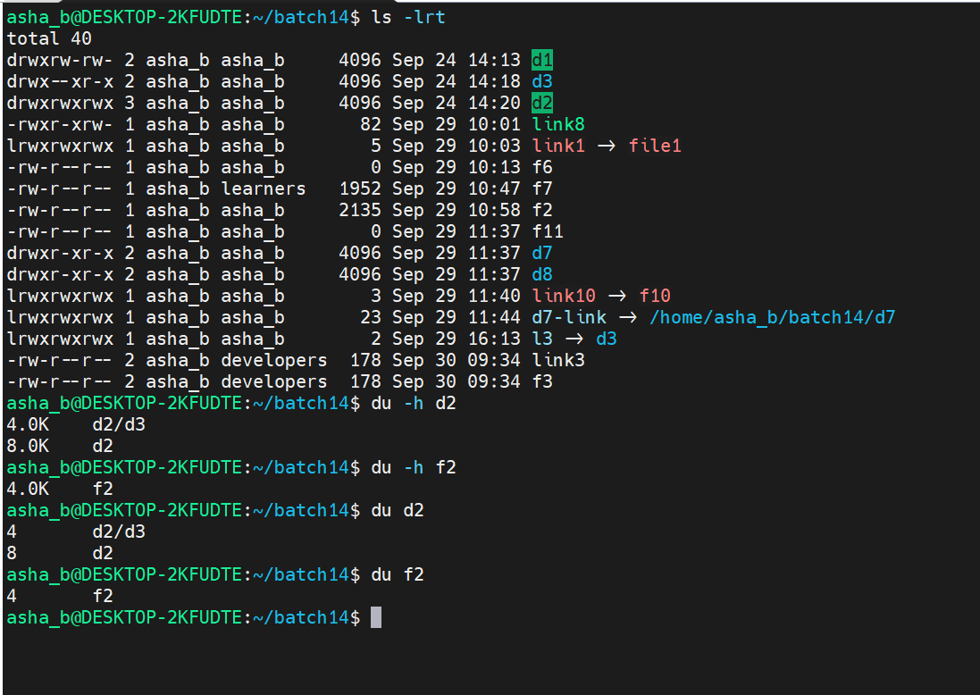

- df [ To display disk space usage of all mounted filesystems in 1K blocks ]

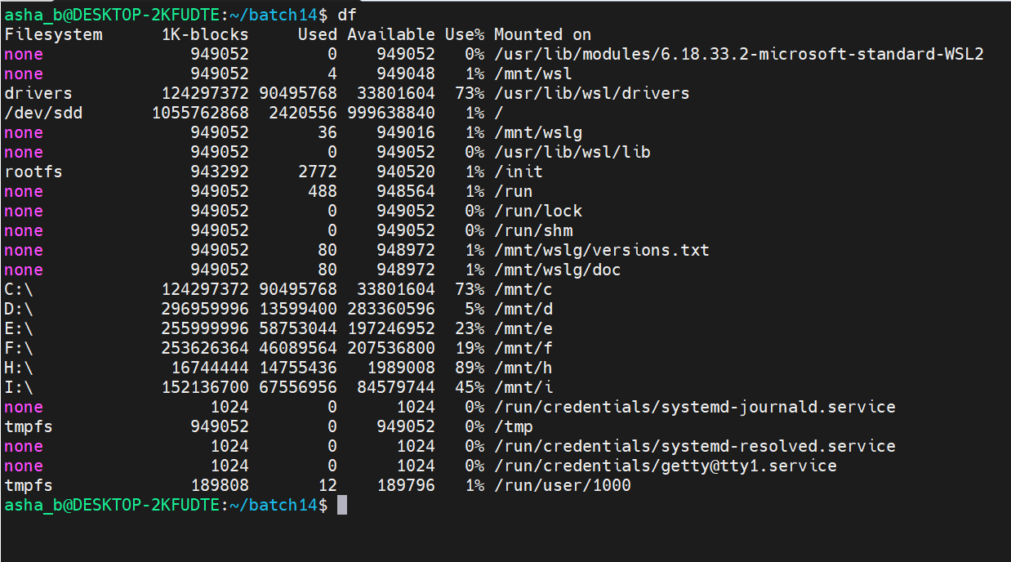
- df -h [ To display disk space usage of all mounted filesystems in a human-readable format ]

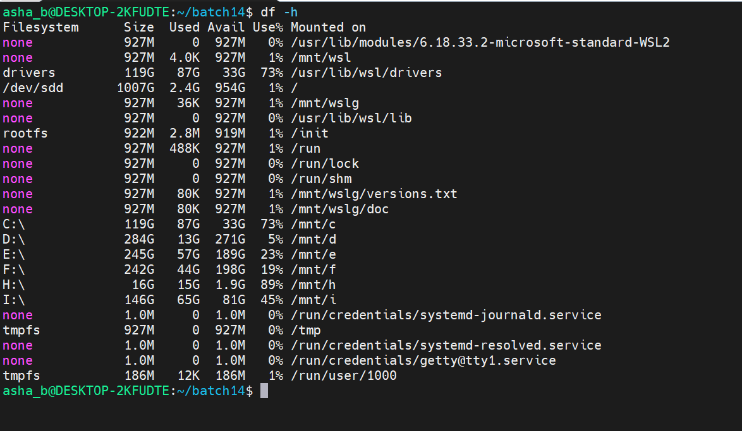

- Monitor running processes and system resource usage

- top [ To display a real-time, continuously updating list of running processes along with CPU and memory usage ]
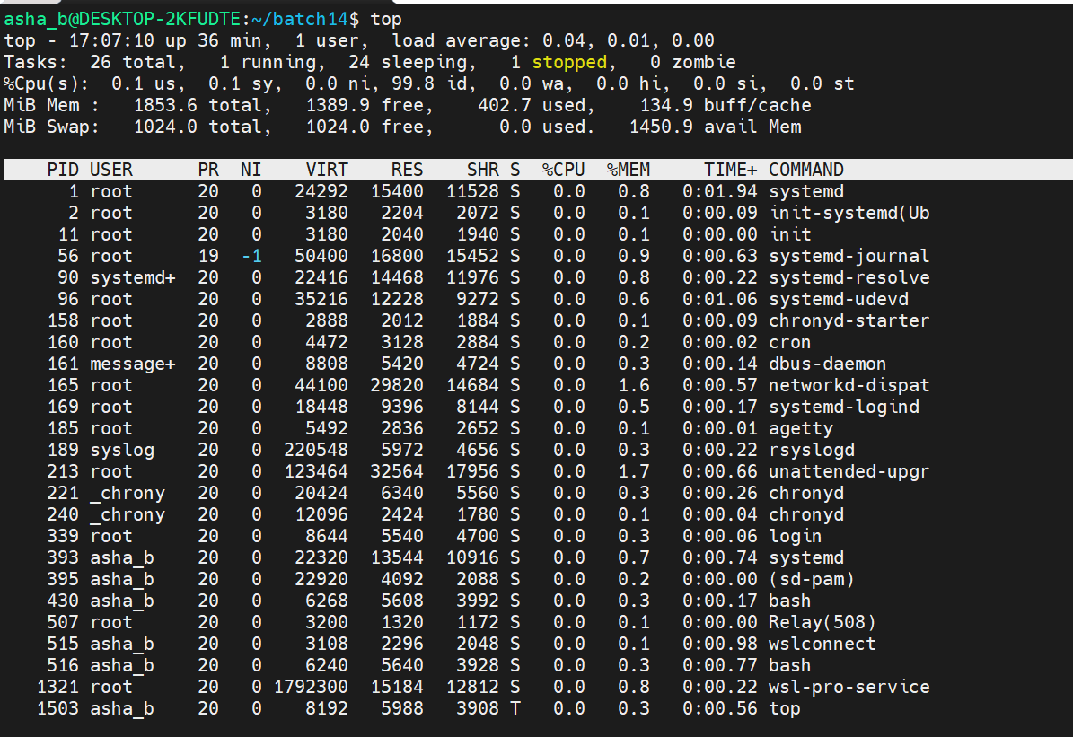

- top | head -15 [ To capture a single snapshot of top's output and display only the first 15 lines ]

